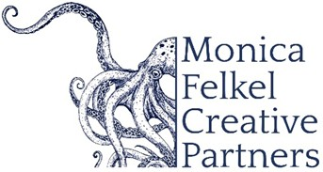

NORMAN HUYNH, conductor

American conductor Norman Huynh has earned acclaim for his natural musicality, technical command, and dynamic presence on the podium. Renowned for his creative programming and his ability to connect with audiences of all backgrounds, he currently serves as Music Director of the Bozeman Symphony and the Britt Festival Orchestra.
He has appeared with distinguished orchestras and ensembles across North America, Europe, and Asia, including the St. Louis Symphony, New York Philharmonic, San Diego Symphony, Detroit Symphony, Los Angeles Chamber Orchestra, and Spain’s Orchestra Sinfónica del Vallés. The 26-27 season include debuts at the Hollywood Bowl with the Los Angeles Philharmonic, Canada’s Vancouver and Victoria symphonies, and return engagements with the Minnesota Orchestra, Edmonton and Oregon symphonies.

Huynh’s versatility spans classical masterworks, premiers of contemporary works, and cross-genre collaborations with artists such as Itzhak Perlman and Augustin Hadelich; composers Kevin Puts, Andy Akiho, and Philip Glass; as well as artists in R&B, hip-hop, indie and popular music.. He is also acclaimed for conducting live orchestral performances of major film scores, including An American in Paris and the Harry Potter series.
A proud first-generation Asian American, Huynh began his musical journey as a trombonist in Alabama. He co-founded Baltimore’s Occasional Symphony, known for imaginative concerts in non-traditional spaces, and helped develop the Portland Symphony Orchestra’s award-winning PSO Explorers Program for young audiences.

Huynh resides in Bozeman, Montana, with his wife Catherine Young, and their son, Romeo.

06/2026
NOTE: Please discard previously dated materials and contact artist’s management before making any alterations or cuts. Please do not use previously dated materials.

